Experiment- 7
Branch: MCA (AI&ML) | Semester: 2
Student Name: Ajay Rakwal | UID: 25MCI10329
Subject Name: Technical Training | Subject Code: 25CAP-652
Section/Group: MAM-1(A) | Date of Performance: 31-03-2026

Aim of the program:
Implementation of joins in PostgreSQL (inner join ,left join,right join, self join and cross join)

Software Requirements
- Operating System: Windows / Linux
- Database Management System: MySQL / Oracle / PostgreSQL
- SQL Interface: MySQL Workbench /Web Based / pgAdmin

Objective
Apply joins to a real-world database schema (e.g., Students, Courses, Enrollments, Departments)

Procedure of the Practical
- Open PostgreSQL (pgAdmin) and connect to the required database.
- Create necessary tables such as Students, Courses, Enrollments, and Departments, and insert sample records.
- Execute an INNER JOIN query to display students along with their enrolled courses.
- Use a LEFT JOIN to find students who are not enrolled in any course.
- Apply a RIGHT JOIN to display all courses, including those without enrolled students.
- Use SELF JOIN or multiple joins to display students along with their department information.
- Execute a CROSS JOIN to generate all possible combinations of students and courses and analyze the output.

Practical / Experiment Steps
--creating tables
CREATE TABLE departments (
department_id SERIAL PRIMARY KEY,
department_name VARCHAR(40)
);
CREATE TABLE students (
student_id SERIAL PRIMARY KEY,
name VARCHAR(40),
department_id INT,
FOREIGN KEY (department_id) REFERENCES departments(department_id)
);
CREATE TABLE courses (
course_id SERIAL PRIMARY KEY,
course_name VARCHAR(40)
);

CREATE TABLE enrollments (
student_id INT,
course_id INT,
PRIMARY KEY (student_id, course_id),
FOREIGN KEY (student_id) REFERENCES students(student_id),
FOREIGN KEY (course_id) REFERENCES courses(course_id)
);

--inserting values into tables
INSERT INTO departments (department_name) VALUES
('Computer Science'),
('Mechanical'),
('Electrical');
INSERT INTO students (name, department_id) VALUES
('Ajay', 1),
('Jatin', 2),
('Purnima', 1),
('Yuvraj', 3),
('Daniel', NULL);

INSERT INTO courses (course_name) VALUES
('DBMS'),
('OS'),
('Maths'),
('AI');
INSERT INTO enrollments (student_id, course_id) VALUES
(1, 1),
(1, 2),
(2, 3),
(3, 1);

--students with their enrolled courses (INNER JOIN)
SELECT
s.student_id,
s.name,
c.course_name
FROM students s
INNER JOIN enrollments e
ON s.student_id = e.student_id
INNER JOIN courses c
ON e.course_id = c.course_id;

--students not enrolled in any course (LEFT JOIN).
SELECT
s.student_id,
s.name
FROM students s
LEFT JOIN enrollments e
ON s.student_id = e.student_id
WHERE e.student_id IS NULL;

-- all courses with or without enrolled students (RIGHT JOIN).
SELECT
c.course_name,
s.name AS student_name
FROM enrollments e
RIGHT JOIN courses c
ON e.course_id = c.course_id
LEFT JOIN students s
ON e.student_id = s.student_id;

--students with department info using SELF JOIN or multiple joins.
SELECT
s1.name AS student1,
s2.name AS student2
FROM students s1
JOIN students s2
ON s1.department_id = s2.department_id
WHERE s1.student_id <> s2.student_id;

--all possible student-course combinations (CROSS JOIN)
SELECT
s.name,
c.course_name
FROM students s
CROSS JOIN courses c;

I/O Analysis (Input / Output)
Input
• Base table creation queries for departments, students, courses, and enrollments
• Sample data insertion commands for all tables
• INNER JOIN query to display students with their enrolled courses
• LEFT JOIN query to find students not enrolled in any course
• RIGHT JOIN query to display all courses with or without enrolled students
• SELF JOIN query to find students belonging to the same department
• CROSS JOIN query to generate all possible student-course combinations

Output
- Base tables created successfully with primary and foreign key constraints
- Sample data inserted into all tables successfully
- INNER JOIN displaying students along with their enrolled courses
- LEFT JOIN identifying students with no course enrollments
- RIGHT JOIN showing all courses including those without students
- SELF JOIN displaying pairs of students from the same department
- CROSS JOIN generating all possible combinations of students and courses
- Effective demonstration of different JOIN operations for relational data retrieval
OUTPUT:
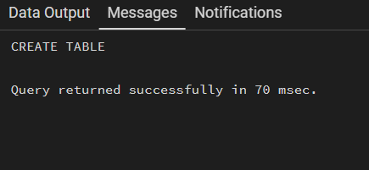
Table Created:

students with their enrolled courses (INNER JOIN):
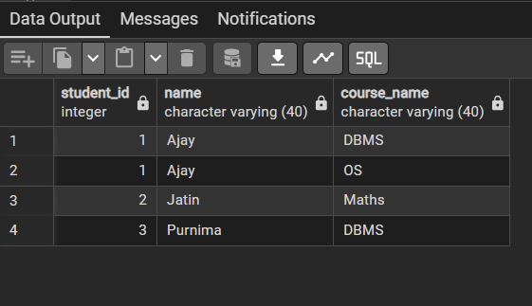

-- students not enrolled in any course (LEFT JOIN).
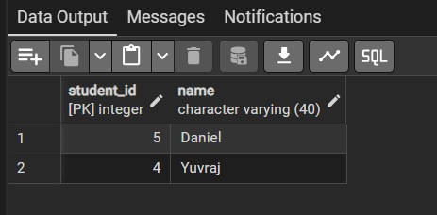

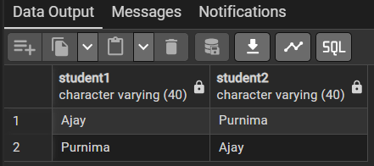
--students with department info using SELF JOIN or multiple joins.

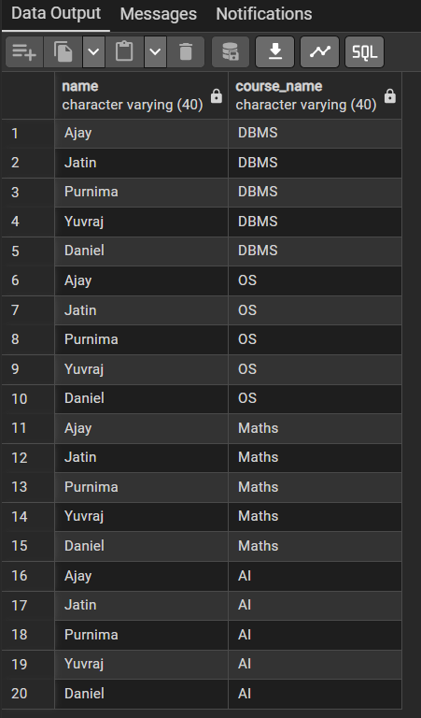
--all possible student-course combinations (CROSS JOIN)

--Summary View

Learning Outcome:
- Understand the concept and purpose of different types of joins in SQL.
- Learn how to apply INNER, LEFT, RIGHT, SELF, and CROSS JOINs in PostgreSQL.
- Gain practical experience in retrieving related data from multiple tables.
- Develop the ability to handle real-world relational database scenarios using joins.
- Understand how joins help in data integration and query optimization in database systems.

